Truncated Icosidodecahedron

Definition
# Source: AI Source: Provided by: [Data Path: Persons Table -> ID Column: 1, Name_En Column: Motasem Essam] -> From: [ChatGPT] on [7/25/2026]
A Truncated Icosidodecahedron is a three-dimensional polyhedron formed by truncating the vertices of an original icosidodecahedron using planes.
The truncation process creates new polygonal faces while modifying the original triangular and pentagonal faces.
It is classified as a uniform polyhedron and belongs to the family of Archimedean solids.

Geometric Structure
# Source: AI Source: Provided by: [Data Path: Persons Table -> ID Column: 1, Name_En Column: Motasem Essam] -> From: [ChatGPT] on [7/25/2026]
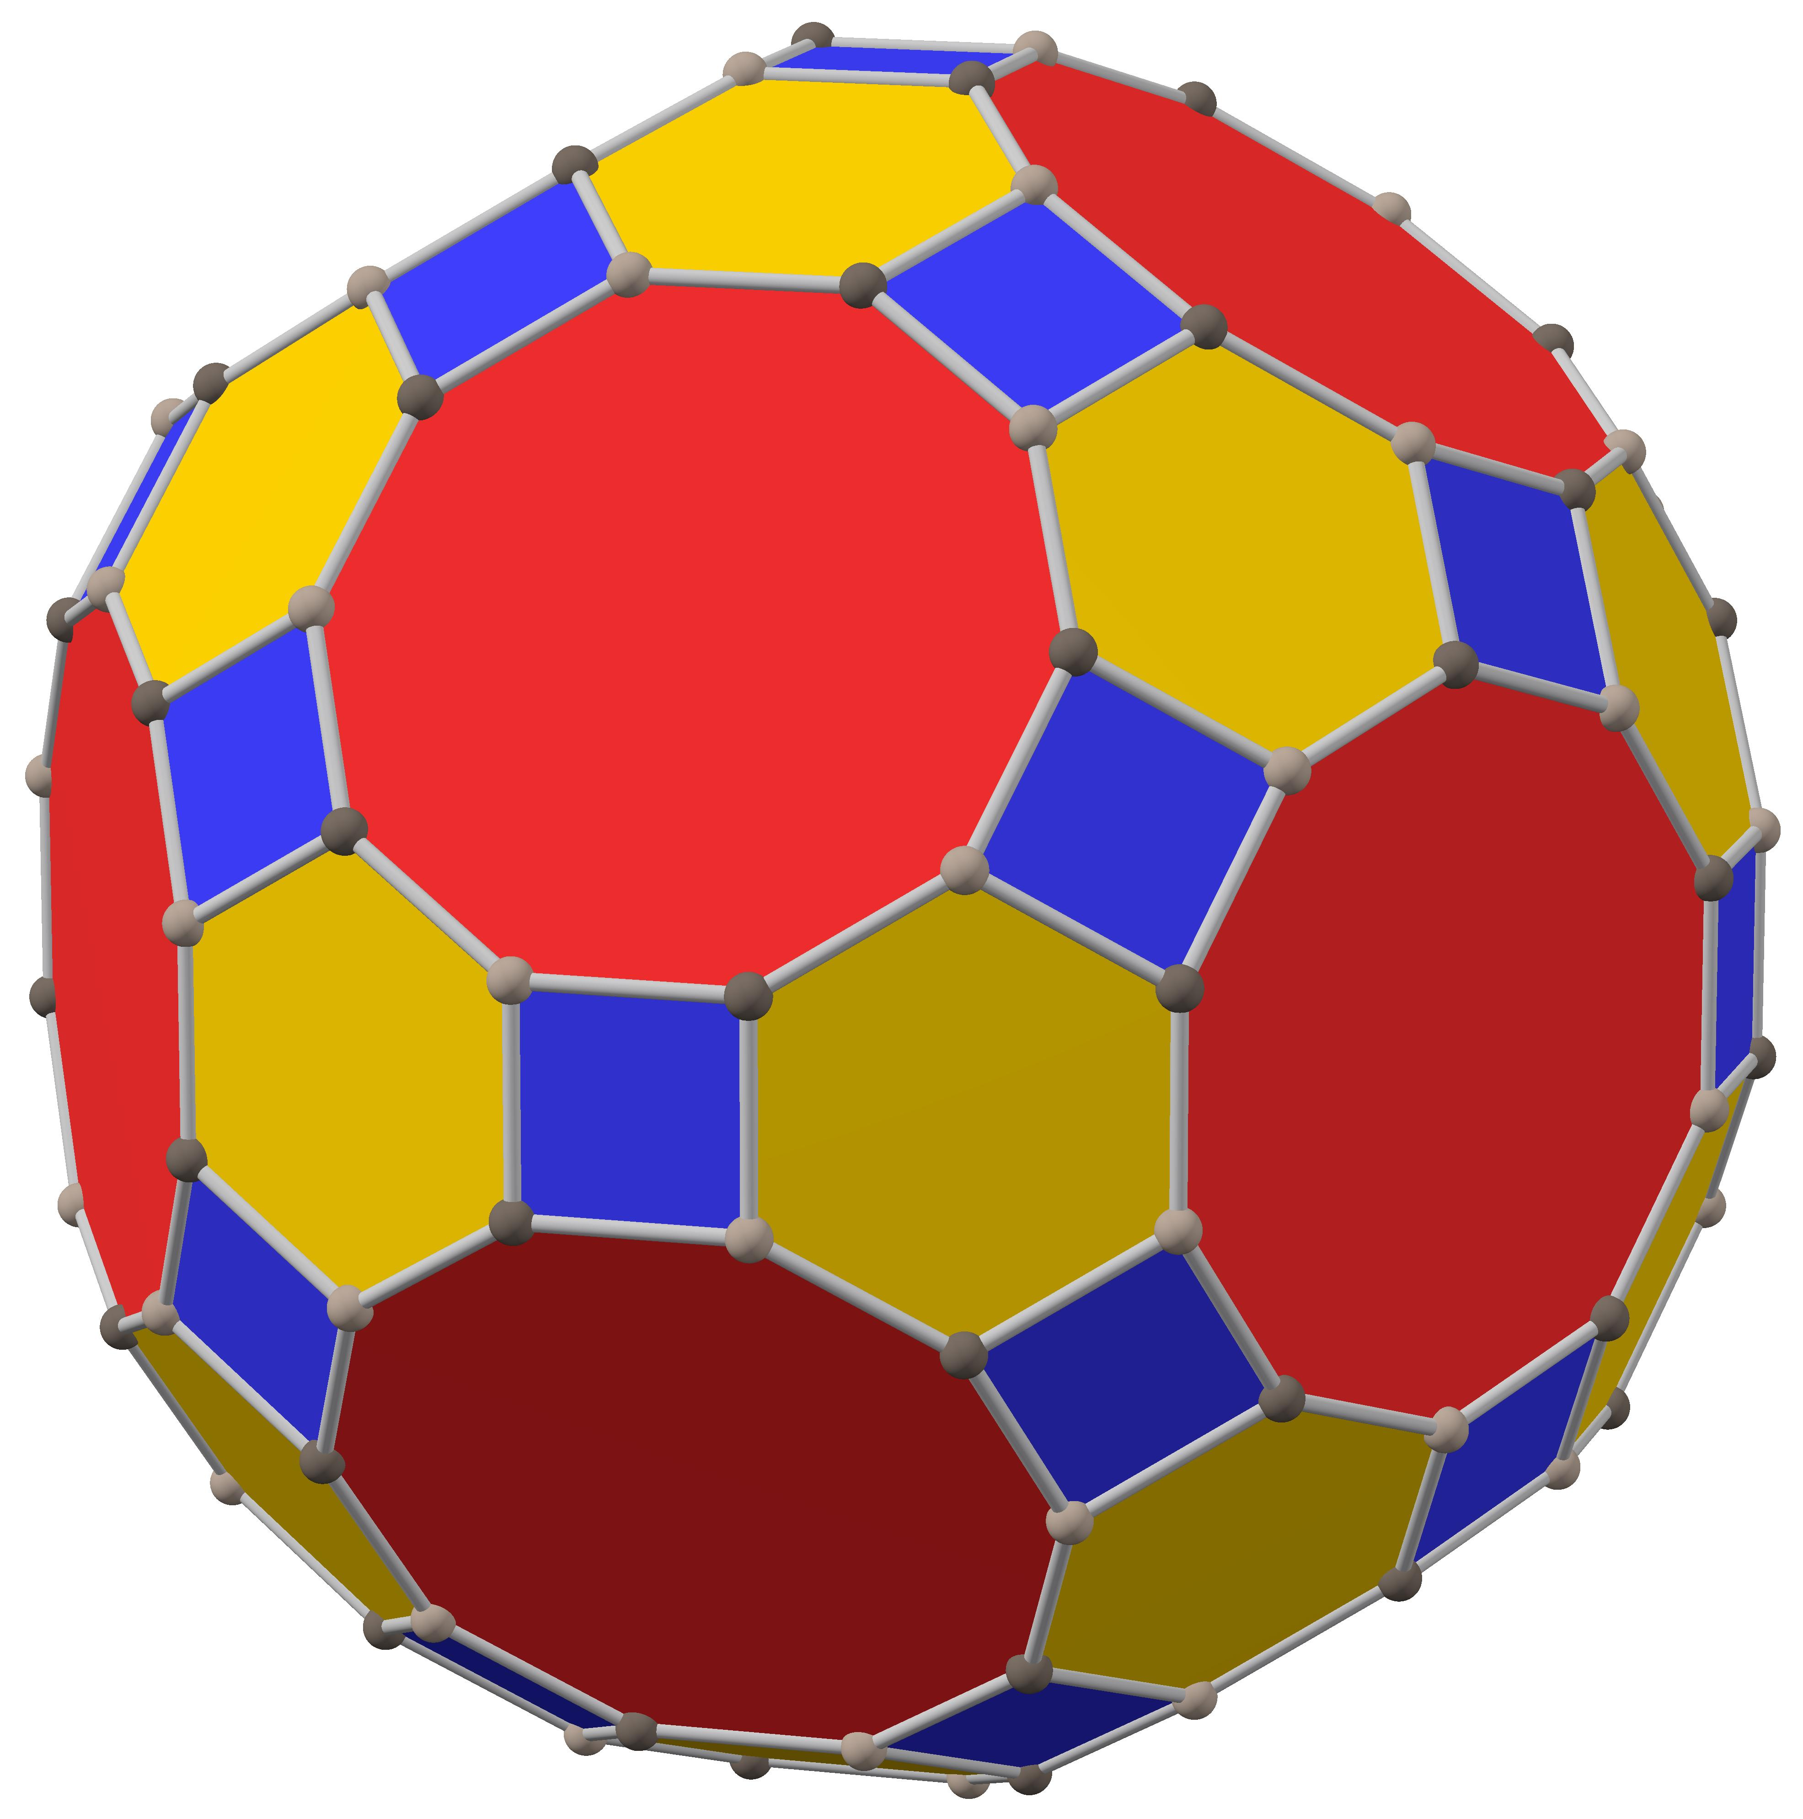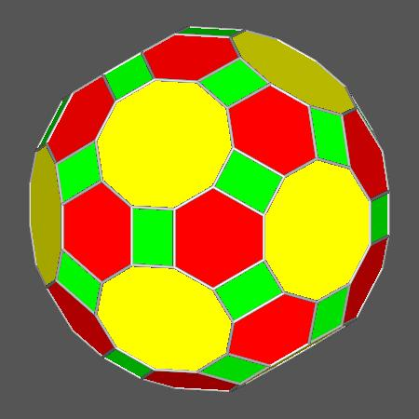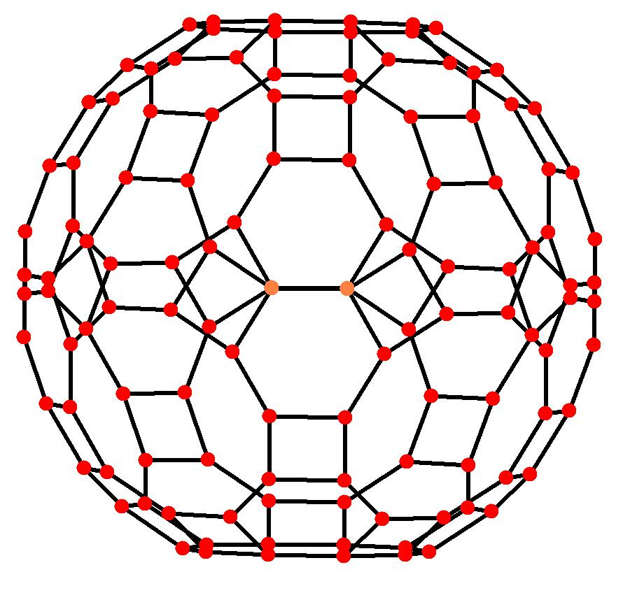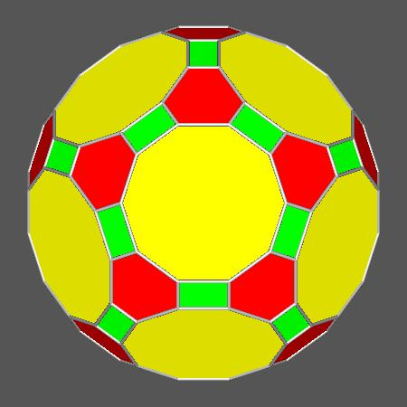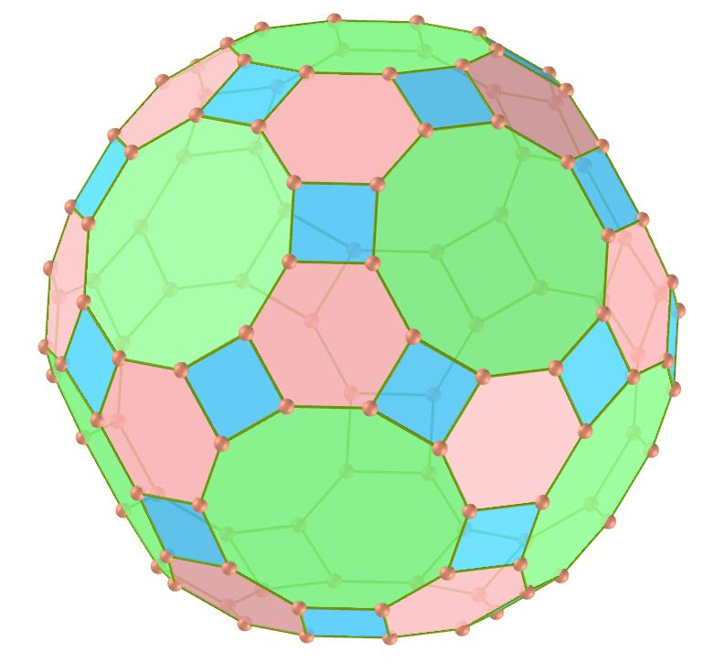

Geometric Structure and Face Composition
# Source: AI Source: Provided by: [Data Path: Persons Table -> ID Column: 1, Name_En Column: Motasem Essam] -> From: [ChatGPT] on [7/25/2026]
The truncated icosidodecahedron consists of three types of polygonal faces:
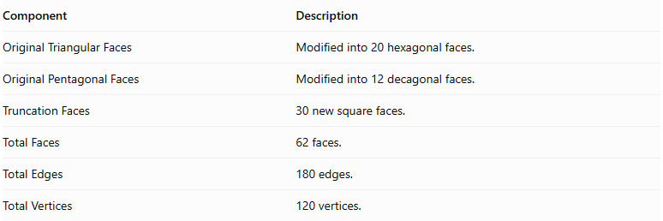
Component | Description
Original Triangular Faces | Modified into 20 hexagonal faces.
Original Pentagonal Faces | Modified into 12 decagonal faces.
Truncation Faces | 30 new square faces.
Total Faces | 62 faces.
Total Edges | 180 edges.
Total Vertices | 120 vertices.
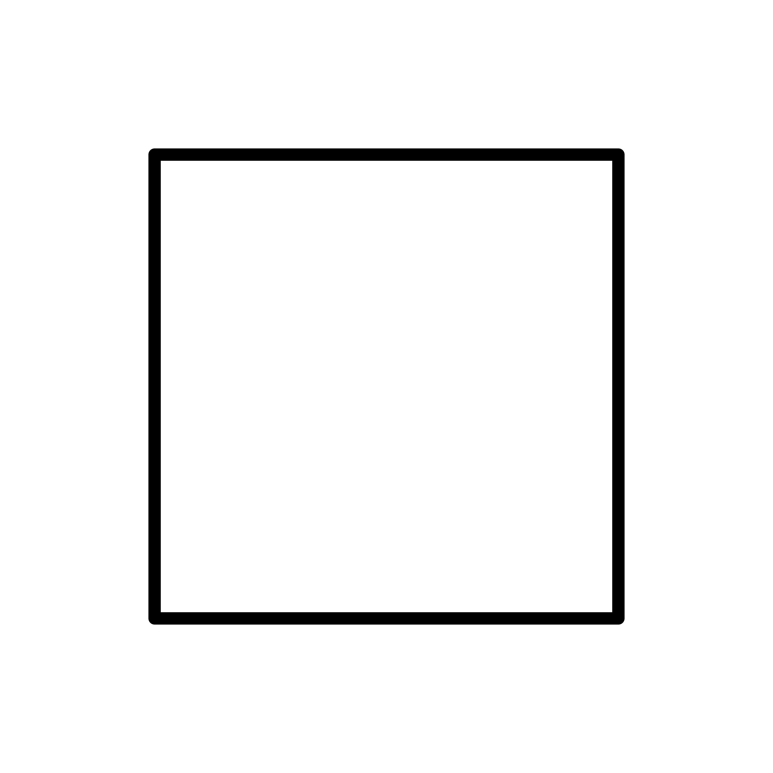

Square Faces
# Source: AI Source: Provided by: [Data Path: Persons Table -> ID Column: 1, Name_En Column: Motasem Essam] -> From: [ChatGPT] on [7/25/2026]
- Number: 30
- Shape: Regular squares.
- Origin: Created around the original vertices.
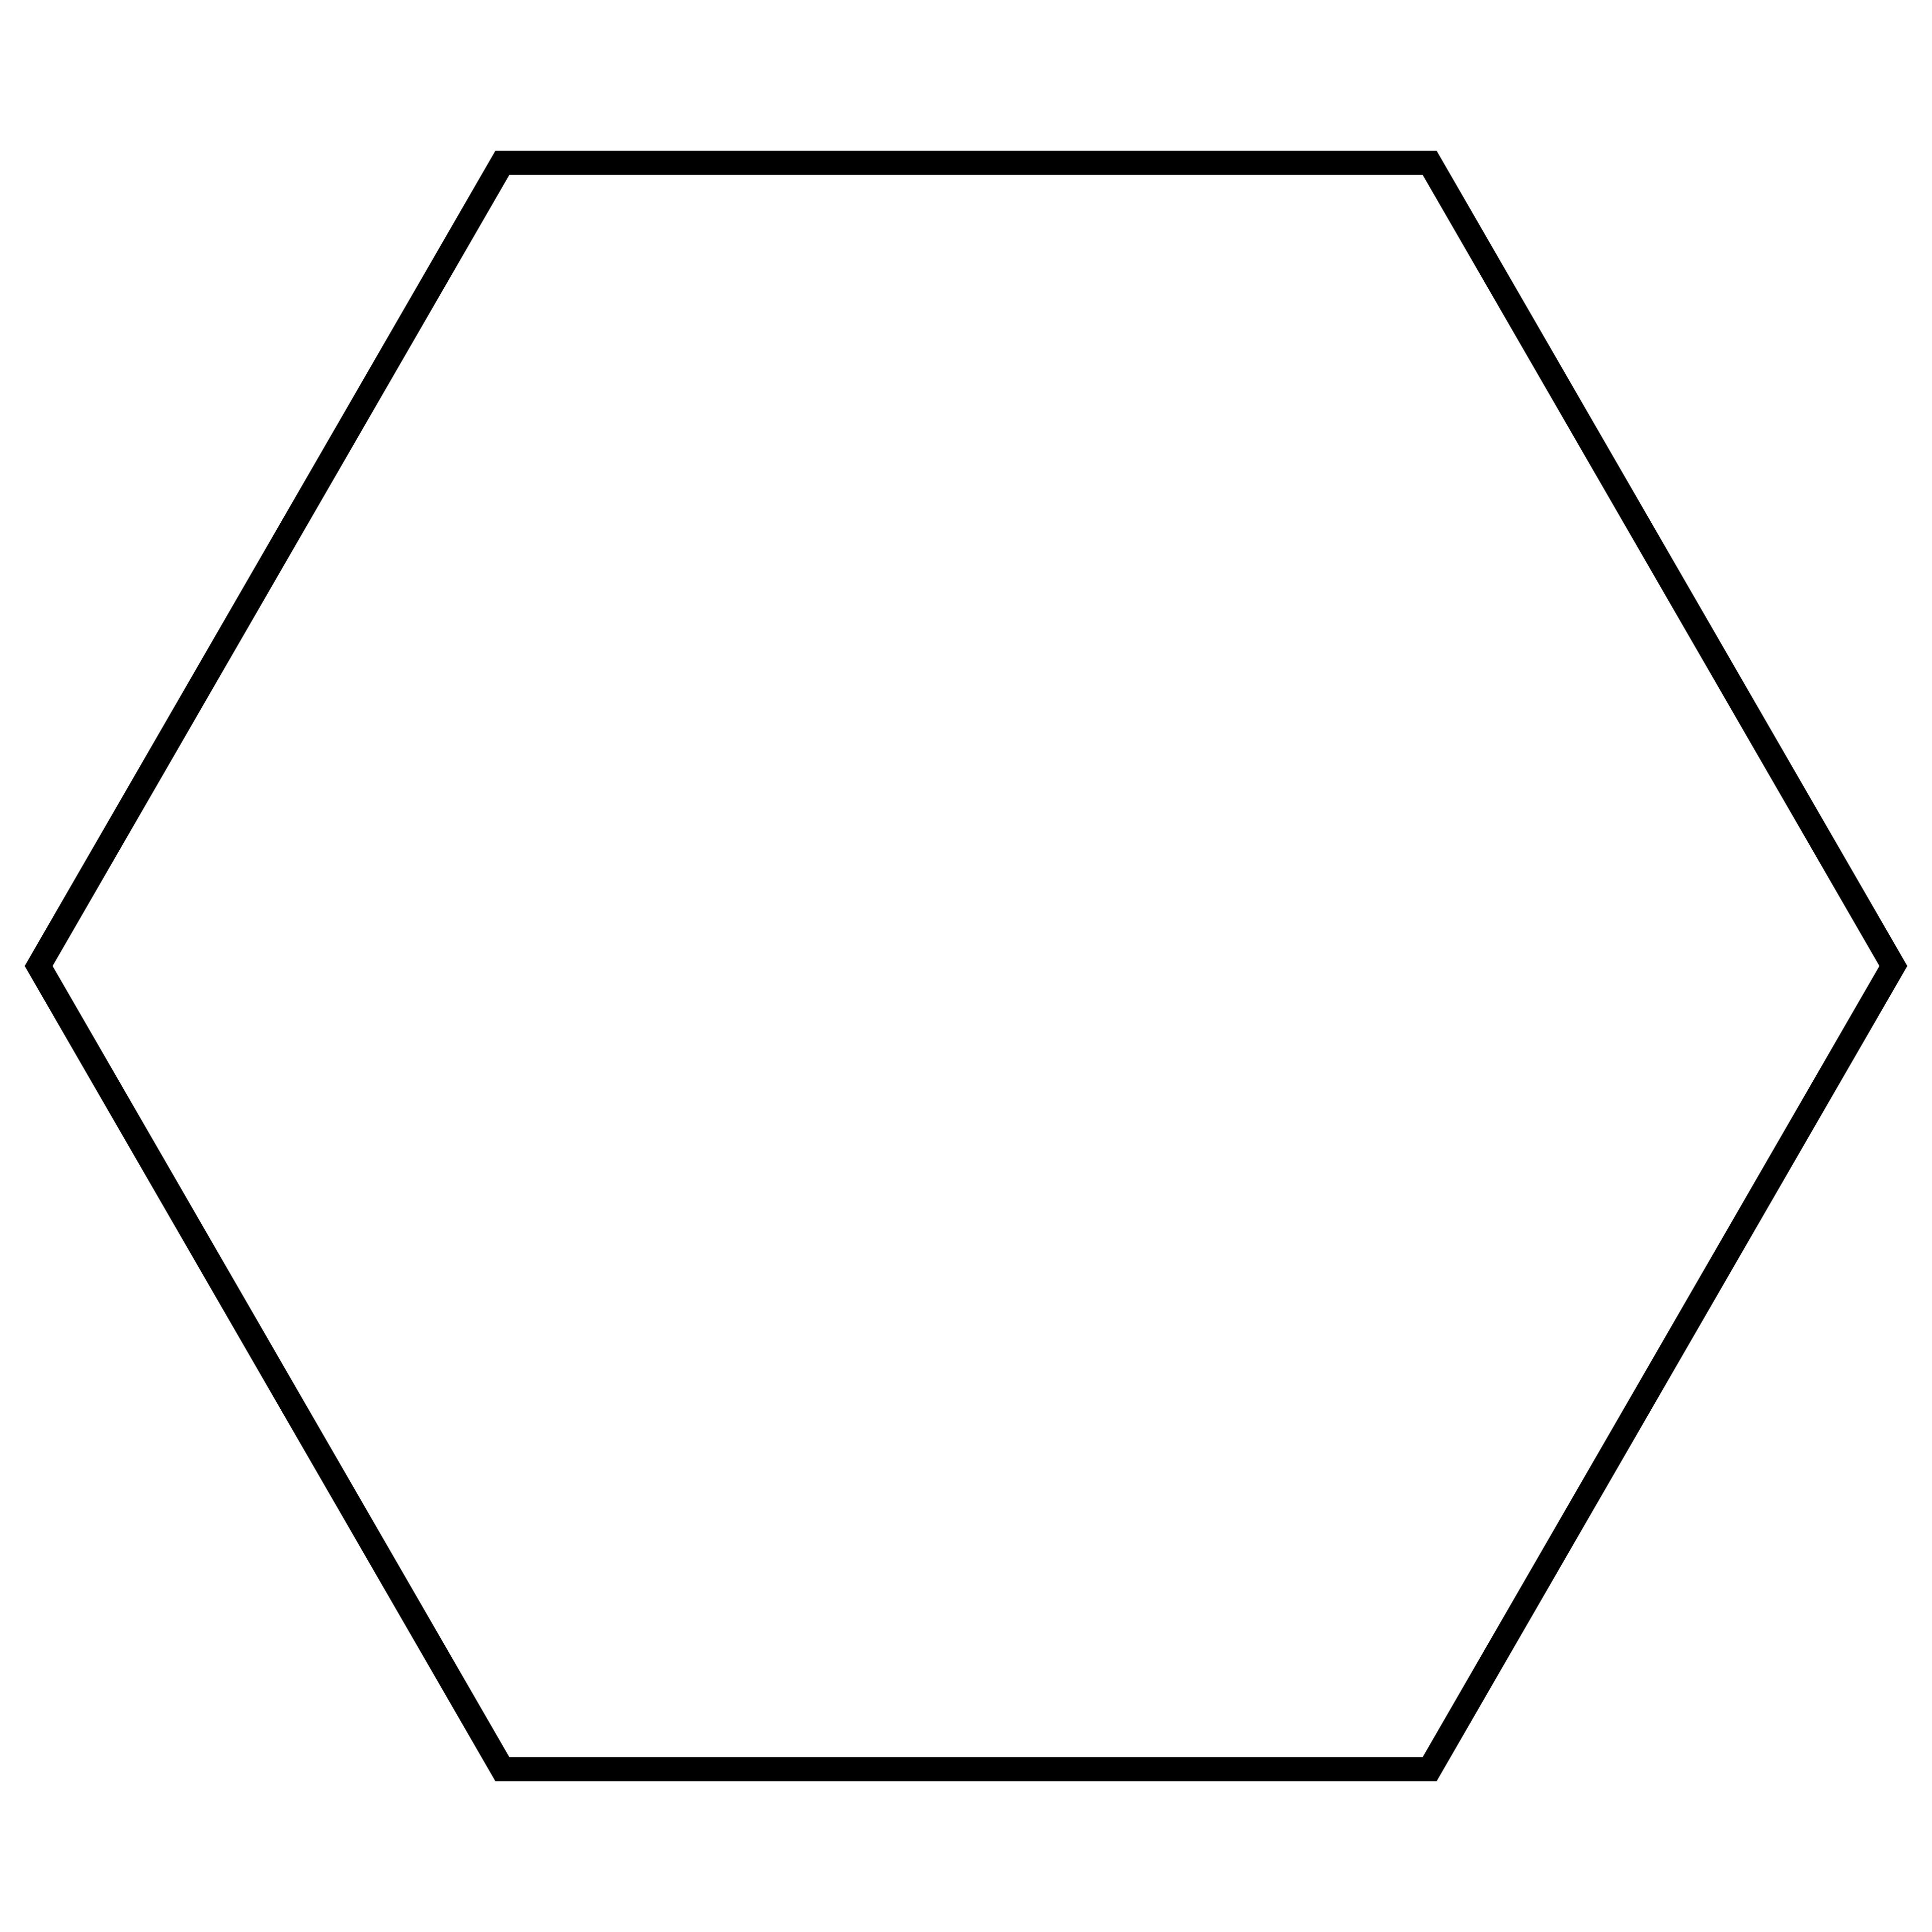

Hexagonal Faces
# Source: AI Source: Provided by: [Data Path: Persons Table -> ID Column: 1, Name_En Column: Motasem Essam] -> From: [ChatGPT] on [7/25/2026]
- Number: 20
- Shape: Regular hexagons.
- Origin: Derived from the original triangular faces.
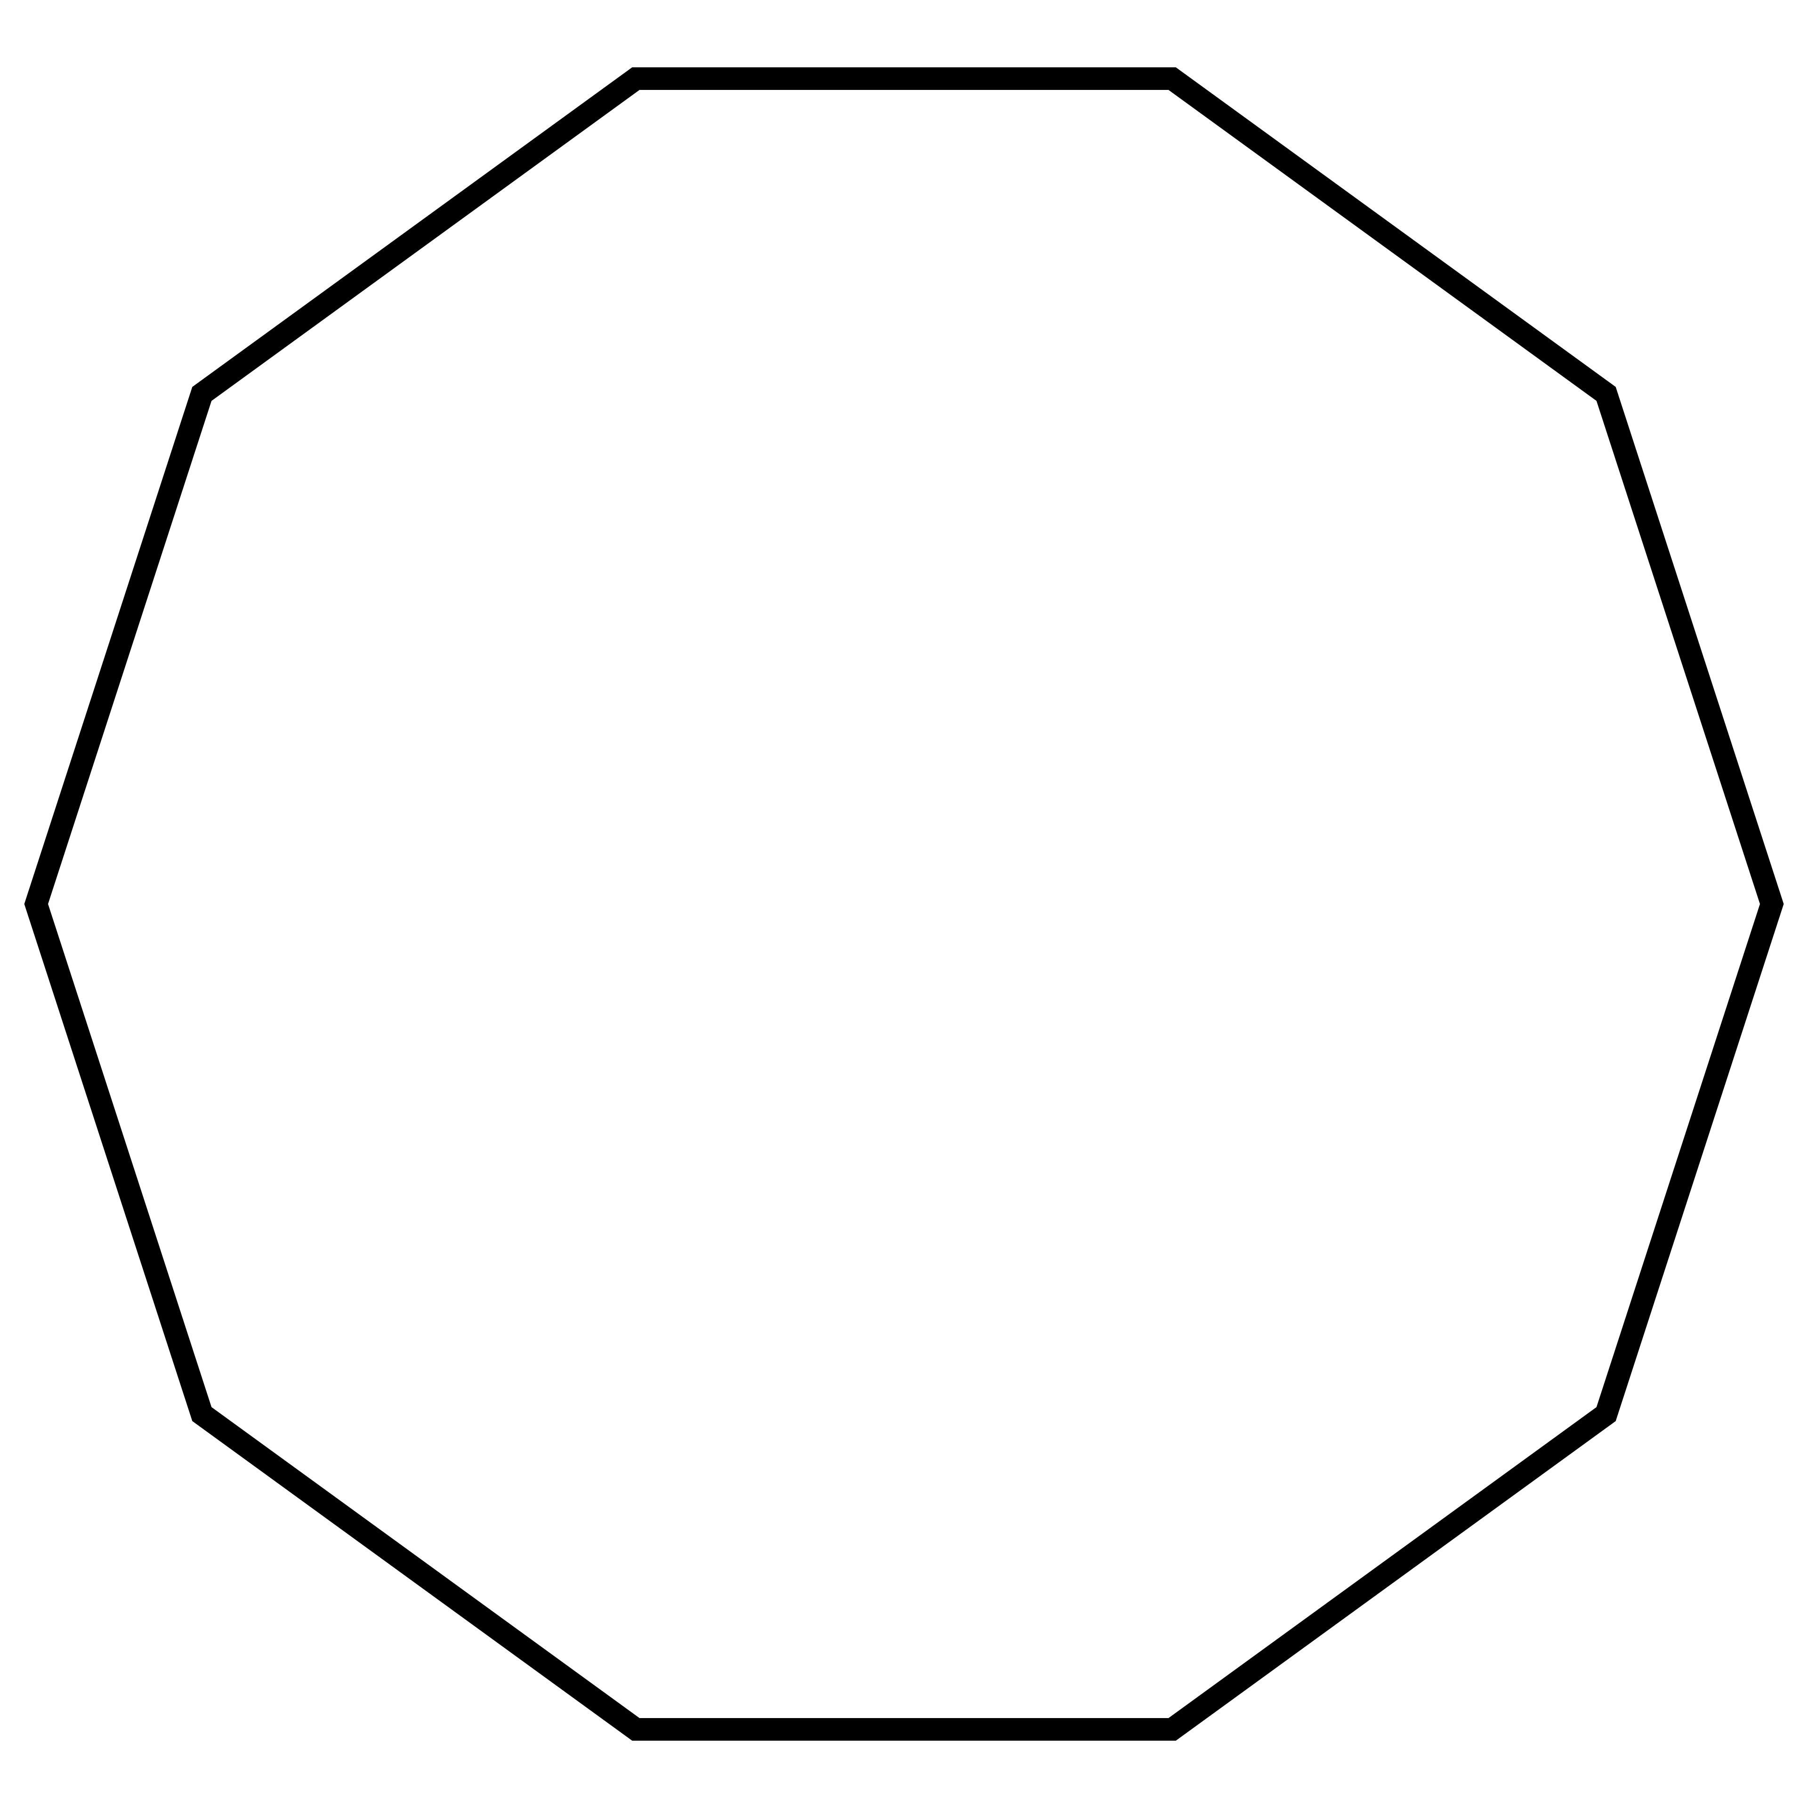

Decagonal Faces
# Source: AI Source: Provided by: [Data Path: Persons Table -> ID Column: 1, Name_En Column: Motasem Essam] -> From: [ChatGPT] on [7/25/2026]
- Number: 12
- Shape: Regular decagons.
- Origin: Derived from the original pentagonal faces.

Mathematical Properties
# Source: AI Source: Provided by: [Data Path: Persons Table -> ID Column: 1, Name_En Column: Motasem Essam] -> From: [ChatGPT] on [7/25/2026]
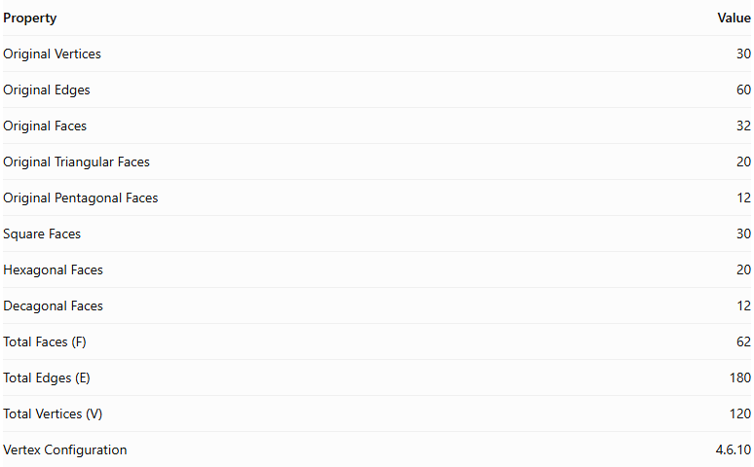
Property | Value
Original Vertices | 30
Original Edges | 60
Original Faces | 32
Original Triangular Faces | 20
Original Pentagonal Faces | 12
Square Faces | 30
Hexagonal Faces | 20
Decagonal Faces | 12
Total Faces (F) | 62
Total Edges (E) | 180
Total Vertices (V) | 120
Vertex Configuration | 4.6.10
Euler's Formula:
$$V-E+F=2$$
Substituting:
$$120-180+62=2$$
Therefore, the truncated icosidodecahedron satisfies Euler's formula.

Key Points
# Source: AI Source: Provided by: [Data Path: Persons Table -> ID Column: 1, Name_En Column: Motasem Essam] -> From: [ChatGPT] on [7/25/2026]
- It is associated with an original icosidodecahedron.
- It has 30 square faces, 20 regular hexagonal faces, and 12 regular decagonal faces.
- It contains 180 edges and 120 vertices.
- It has 62 faces in total.
- Three different types of polygons meet at each vertex.
- It is also known as the Great Rhombicosidodecahedron.
- It has one of the largest numbers of faces, edges, and vertices among the Archimedean solids.

Important Geometric Note
# Source: AI Source: Provided by: [Data Path: Persons Table -> ID Column: 1, Name_En Column: Motasem Essam] -> From: [ChatGPT] on [7/25/2026]
The truncated icosidodecahedron requires more than ordinary uniform vertex truncation to produce its regular polygonal faces. Additional geometric adjustments are needed to obtain the uniform solid. Therefore, it is better to describe it as a related truncation construction rather than a simple vertex-truncated icosidodecahedron. <Cite refs={["turn366561search0","turn366561search2","turn366561search3"]}/>

Conclusion
# Source: AI Source: Provided by: [Data Path: Persons Table -> ID Column: 1, Name_En Column: Motasem Essam] -> From: [ChatGPT] on [7/25/2026]
The Truncated Icosidodecahedron is a uniform polyhedron also known as the Great Rhombicosidodecahedron. It consists of 30 square faces, 20 regular hexagonal faces, and 12 regular decagonal faces, with a total of 62 faces, 180 edges, and 120 vertices.

